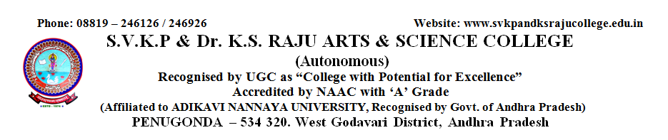

**DEPARTMENT OF ENGLISH**

**RESULT REVIEW : 2021-2022**

**I B.A., B.Sc., & B.Com : SEMESTER-I : GENERAL ENGLISH-I**

|  |  |  |  |  |
| --- | --- | --- | --- | --- |
| Course | Subject | I-SEMESTER | | |
| **Appeared** | **Passed** | **Pass%** |
| I B.A., | GENERAL ENGLISH-I | 33 | 23 | 70 |
| I B.Com(V) | GENERAL ENGLISH-I | 101 | 88 | 87 |
| I B.Com(G) | GENERAL ENGLISH-I | 47 | 31 | 66 |
| I B.Sc., | GENERAL ENGLISH-I | 361 | 343 | 95 |



**DEPARTMENT OF ENGLISH**

**RESULT REVIEW : 2021-2022**

**I B.A., B.Sc., & B.Com : SEMESTER-II : GENERAL ENGLISH-II**

|  |  |  |  |  |
| --- | --- | --- | --- | --- |
| Course | Subject | II-SEMESTER | | |
| **Appeared** | **Passed** | **Pass%** |
| I B.A., | GENERAL ENGLISH-II | 28 | 16 | 57 |
| I B.Com(V) | GENERAL ENGLISH-II | 99 | 65 | 66 |
| I B.Com(G) | GENERAL ENGLISH-II | 46 | 20 | 44 |
| I B.Sc., | GENERAL ENGLISH-II | 350 | 322 | 92 |



**DEPARTMENT OF ENGLISH**

**RESULT REVIEW : 2021-2022**

**II B.A., B.Sc., & B.Com : SEMESTER-III : GENERAL ENGLISH-III**

|  |  |  |  |  |
| --- | --- | --- | --- | --- |
| Course | Subject | III-SEMESTER | | |
| **Appeared** | **Passed** | **Pass%** |
| II B.A., | GENERAL ENGLISH-III | 28 | 23 | 82 |
| II B.Com(V) | GENERAL ENGLISH-III | 92 | 88 | 96 |
| II B.Com(G) | GENERAL ENGLISH-III | 44 | 34 | 77 |
| II B.Sc., | GENERAL ENGLISH-III | 337 | 333 | 99 |



**DEPARTMENT OF ENGLISH**

**RESULT REVIEW : 2021-2022**

**B.A., B.Sc., & B.Com : SEMESTER-I,II&III : GENERAL ENGLISH**

|  |  |  |  |  |  |  |  |  |  |  |
| --- | --- | --- | --- | --- | --- | --- | --- | --- | --- | --- |
| Course | Subject | I-SEMESTER | | | II-SEMESTER | | | III-SEMESTER | | |
| **Appeared** | **Passed** | **Pass%** | **Appeared** | **Passed** | **Pass%** | **Appeared** | **Passed** | **Pass%** |
| B.A., B.Com., B.Sc | ENGLISH | 542 | 485 | 89 | 523 | 483 | 80 | 501 | 478 | 95 |



**DEPARTMENT OF ENGLISH**

**RESULT REVIEW : 2021-2022**

**B.A., B.Sc., & B.Com : SEMESTER-II : PDL**

|  |  |  |  |  |
| --- | --- | --- | --- | --- |
| Course | Subject | II-SEMESTER | | |
| **APPEARED** | **PASSED** | **PASS %** |
| II BA | PDL | 47 | 45 | 96 |
| II B.Com (V) | PDL | 92 | 92 | 100 |
| II B.Com(G) | PDL | 48 | 48 | 100 |
| II B.Sc | PDL | 84 | 83 | 99 |